Narrative Report
Midyear Reading Narrative Report
Grade 11 Humility
2nd Floor SHS Building
October 2026

The midyear reading assessment was conducted in Grade 11 – Humility at Bonbon National High School to determine the reading abilities of learners in English and Filipino. The assessment provided an opportunity to observe their current reading performance, particularly their ability to read words and passages and comprehend what they had read.

The assessment was conducted through individual reading sessions using the ASER reading assessment tool, with the class adviser facilitating the process. Learners were asked to read selected texts and answer comprehension questions to determine their reading proficiency and level of understanding. The assessment took place during the midyear period and served as a means of documenting their reading abilities at this stage of the school year.

Based on the assessment results and classroom observations, most learners demonstrated the ability to read words, sentences, and connected texts. This indicated that they had previous exposure to reading instruction and had developed basic oral reading skills. However, the ability to read a passage aloud did not always translate into understanding its meaning. Many learners could pronounce the words they encountered but still experienced difficulty identifying the main idea, recalling important details, explaining what they had read, and drawing conclusions from the information presented.

Despite these difficulties, encouraging progress was also observed among the learners. Some who previously experienced considerable difficulty in reading comprehension appeared to have progressed from the Frustration level toward the Instructional level. This indicated that they were becoming more capable of understanding texts with guidance and support. Although they were not yet fully independent in comprehension, their progress reflected a developing ability to make meaning from what they read.

In English, most learners demonstrated the ability to read passages aloud, although many continued to experience difficulty understanding vocabulary, identifying important details, and interpreting the meaning of a text. In Filipino, similar difficulties were observed, with more learners requiring substantial support in reading comprehension. These results showed that learners' oral reading abilities were generally more developed than their ability to understand and interpret texts independently.

Overall, the midyear reading assessment revealed that learners had varying levels of reading proficiency. Most could already read connected texts, while some continued to experience difficulties with basic reading skills. At the same time, reading comprehension remained a challenge for many learners, particularly when they were required to explain ideas, recall information, or demonstrate their understanding of a passage. Nevertheless, the observed progress of some learners from the Frustration level toward the Instructional level reflected positive developments in their reading comprehension.

In conclusion, the midyear reading assessment documented both the existing reading abilities and the continuing difficulties of Grade 11 – Humility learners. While most learners had developed basic oral reading skills, many still encountered challenges in comprehending texts in both English and Filipino. The observed progress of some learners toward the Instructional level provided an encouraging indication of their developing comprehension abilities. The assessment served as a record of their reading performance and progress during the midyear period of School Year 2026–2027.

Prepared by: Noted:

DIN SHANE DOMINIC A. MAGALLANES ANGELIKA O. LAGO
Class Adviser School Head

JOVANCE CLARK C. BABEDA
Class Adviser

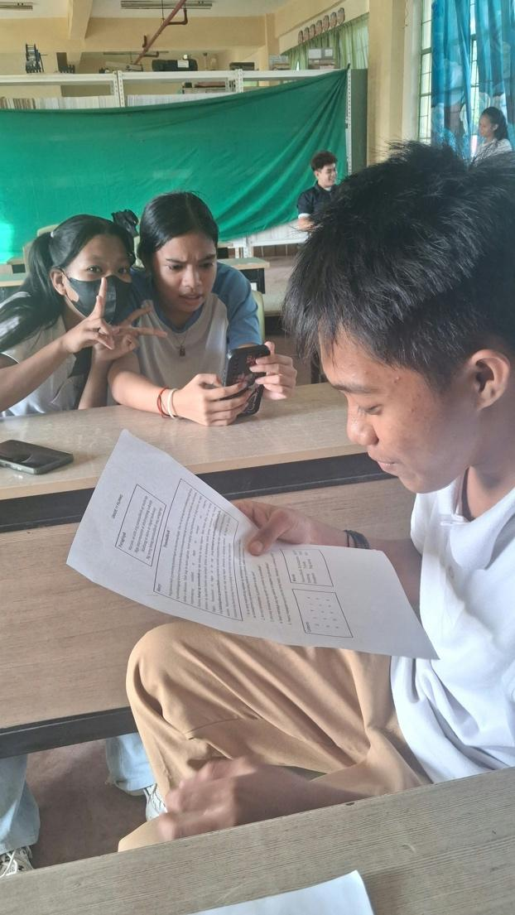

DOCUMENTATION


